1. a) This equation is parallel.

3y + 4x = 12

-6y = 8x + 1

-6y -8x = -24

-6y -8x = 1

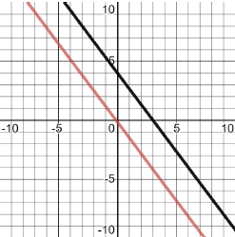

b) This equation is concurrent as it has one point at which the two lines cross.

3y + x = 12

-y = 8x + 1

3y + x = 12

-3y -23x = 3

Point of intersection on graph x = -15/23

3y = 12 – x

Y = 4 – x/3

Y = 4 – (-15/23)/3

Y = 4 + 15/69

Y = (4 x 69 + 15)/69

Y = 291/69

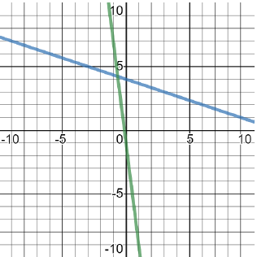

c) This equation is perpendicular.

The formula is already algebraically rigorous as is.

4x – 7y = 10

7x + 4y = 1

4/7 x -7/4 = -1 shows the edges are perpendicular.

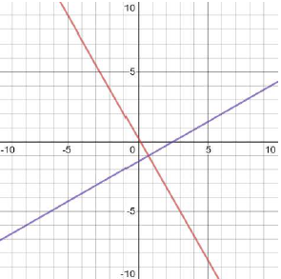

1. h(0) = -4.9 x 0^2 + 24 x 0 + 8 = 8 meters high

x = -b/2a

x = -24/2(-4.9)

x = -24/-9.8

x = 2.45 seconds

h(-b/2a) = -4.9 x 2.45^2 + 58.80 + 8

= -4.9 x 6.00 + 58.80 + 8

= 37.4 maximum height

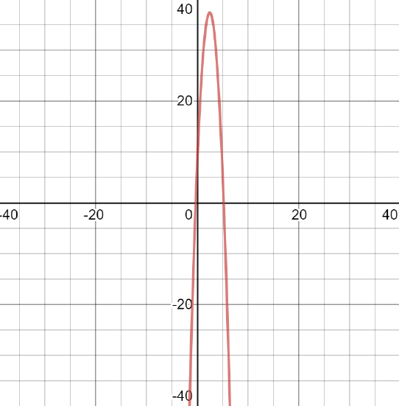

1. I could not get the graph to show anything other than a straight line on this last one…sorry guys